Material Checklist for Euthanasia

* + - Signed authorization form
    - Additional dose
    - Needles, catheters and butterflies of all sizes
    - Stethoscope
    - Alcohol
    - Gauze
    - Tissues
    - Razor
    - 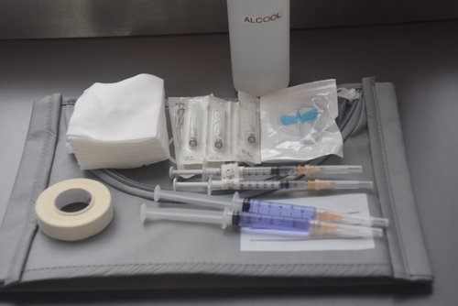Turn off phones